# **Topic**: To become familiar with DW implementation, query execution and result analysis.

# **Objectives:**

To learn physical DW Design

To learn executing queries in DW

To learn analyzing results of DW queries

## **Queries:**

Generate reports using both MDX and Excel Pivot table for the following scenarios:

1: Display the standard cost of all the products along with their categories according to the regions in which they were sold. Which region is the most and the least expensive according to the result retrieved?

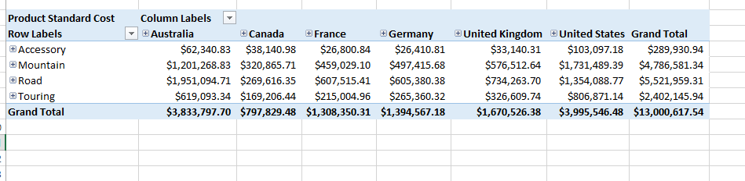

The most expansive region were sold United States.

The least expansive region were sold Canada.

2: Display the Tax amount for customers according to their educations and occupations over calendar year. Do these factors impact the tax amount paid by a customer? Which class of customers pays the highest tax amount?

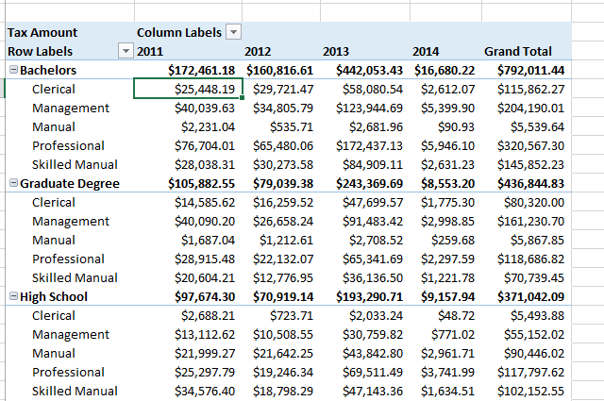

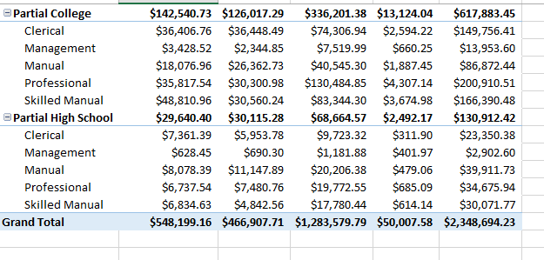

Yes, the factors like education and occupation impact the tax amount paid by a customer.

Bachelors class of customers pays the highest tax amount.

3: Display the sales amount for all products (use product hierarchy) purchased according to the calendar year and filter the results according to the customers’ genders. What type of customers bought the most Biking products?

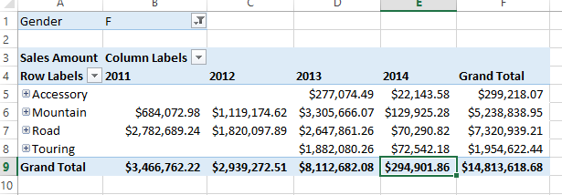

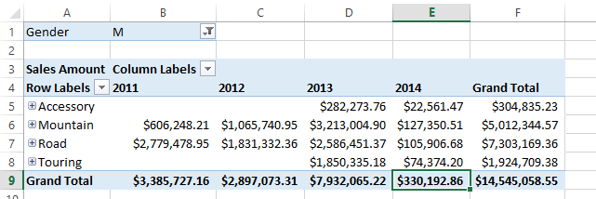 Road customers(F) bought the most Biking products.

4: Display the total days required to manufacture the products (use product hierarchy) according to region and time (use date hierarchy).

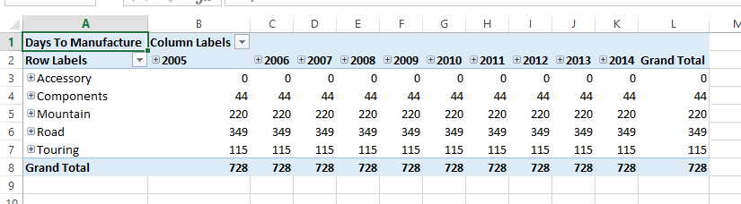

5: Display the order quantity for all the products ordered by customers according to their marital statuses and genders. Filter the results for customers having yearly income greater than or equal to 50,000.

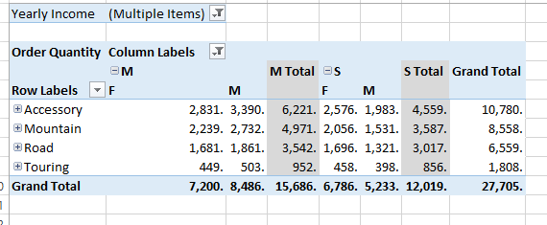

6: Generate pivot charts for any 3 scenarios mentioned above to better visualize the data.

**Result analysis:**

1

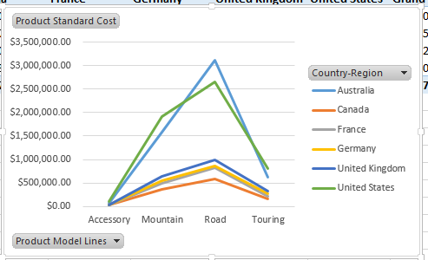

2.

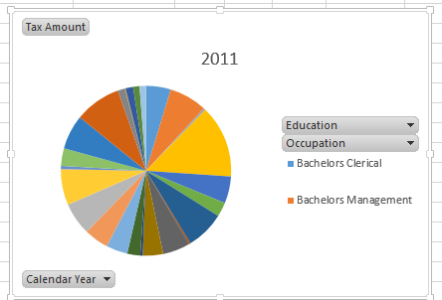

4.

